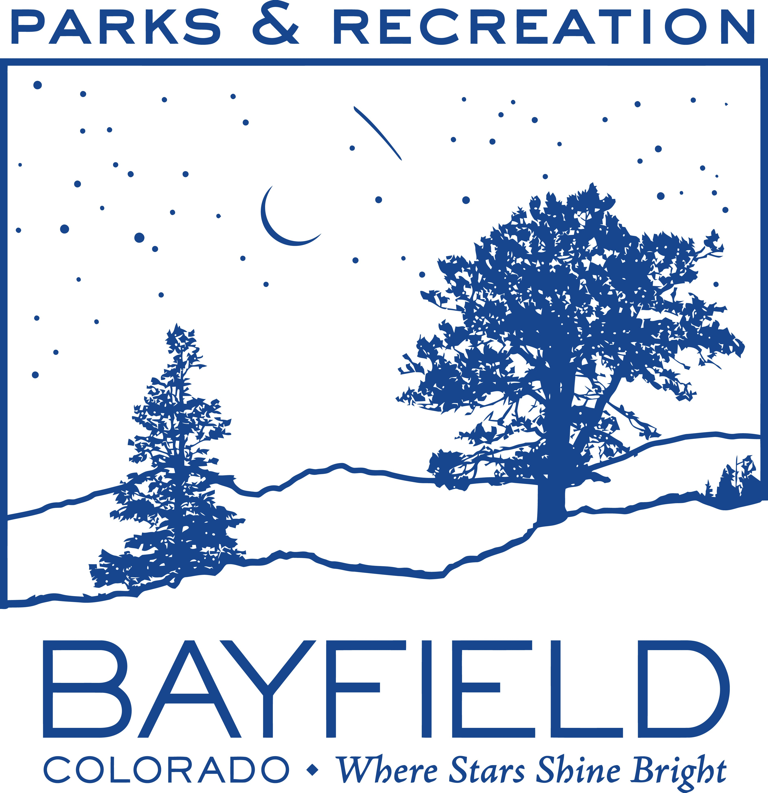
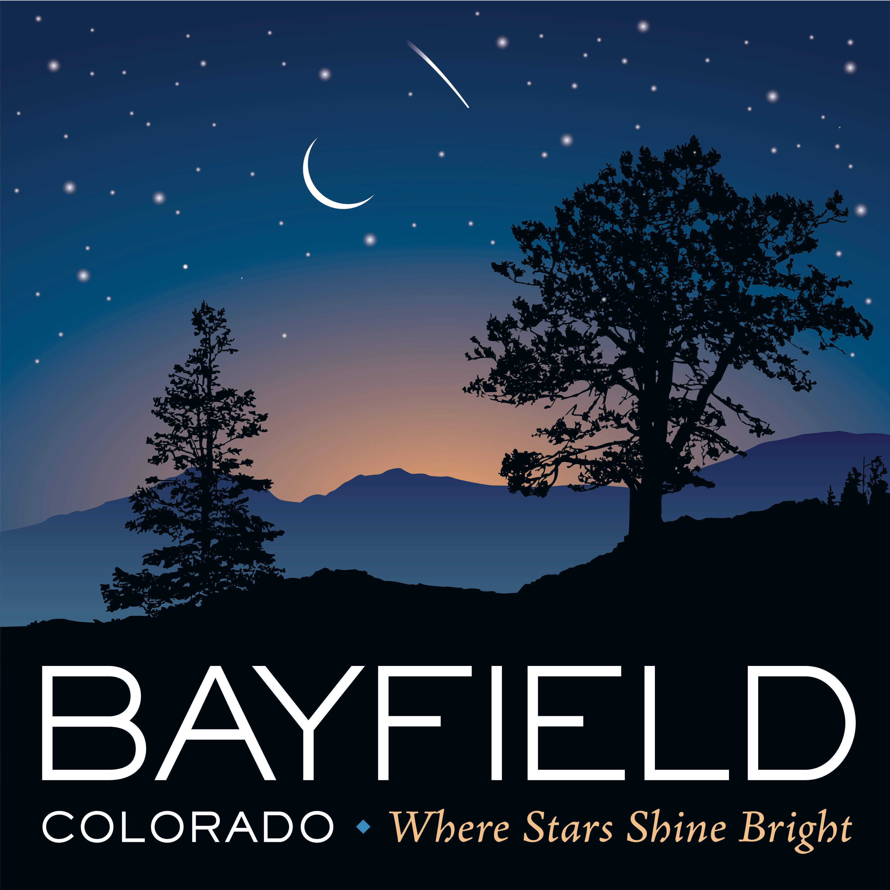
Town of Bayfield

PO Box 80; 1199 Bayfield Parkway; Bayfield, CO 81122

970-884-9544 FAX 970-884-2195

Email: djpacheco@bayfieldgov.org

Eagle Park Pavilion Rental Application

Date: _________

The complete application must be submitted to Bayfield Parks & Recreation a minimum of 10 days prior to rental start date.
A COPY OF THIS AUTHORIZED APPLICATION MUST BE IN THE POSSESSION OF USER
The applicant completing this application must be a minimum of 21 years of age.
Applicant Name |  |  |  | Telephone
Contact Email
Mailing Address
Entity Name |  |  |  | Telephone
Mailing Address
Describe the event or purpose to rent the Eagle Park Pavilion:

Estimated number of people in attendance:
Are loud speakers, live entertainment, or amplified acoustics planned? Yes No
Is the event purpose for solicitation? Yes No
Additional comments or requests:
Provide the requested date and time for the following: (Must include setup and take down)
Start Date/Time |  |  | End Date/Time
Any changes to the rental contract must be made at least one week in advance of the rental date including cancellation. No refund will be given due to inclement weather. |  |  | Deposit |  |  | $50.00
 |  |  | 2-hour minimum |  |  | $50.00
 |  |  | Each Additional Rent Hour ____x $15
 |  |  | Total Due |  |  | $
Colorado Non-profit organizations are required to attach a copy of the certificate of good standing to be eligible for a 20% discount on rental fees. |  |  | Non-Profit Discount Deduct 20% Rental Only |  |  | -$
 |  |  | Non-Profit Total Due |  |  | $
 |  |  | Payment due with application. Checks payable to Town of Bayfield

I agree to the conditions per Page 2 as indicated by my initials and agree that I have completed this application truthfully. Please sign and date.

________________________________________________________________ _____________________
Office Use Only
Method of Payment – VISA / MC / Discover / Cash / Check #_____________$__________ Date:___________
Key Checked Out ID:__________Date:__________ Key Check In ID:____________ Date:___________
Approval Signature___________________________________________Deposit Returned: ___Yes ___No
Applicant Signature Date
Eagle Park Pavilion Rental Application
Applicant Agrees to the Following (Please Initial Each Item):

__ I or a responsible adult will be present at all times during the rental term.
__ I understand that fire pits, pyrotechnics, or flammables are not allowed.
__ I will not sell any food or concessions without prior permission.
__ I will keep any pets leashed at all times and I am responsible for cleaning up after them.
__ I will keep vehicles off turf and landscaping.
__ I will not obstruct any paths within the park.
__ I understand that stakes, tent pegs, or signs are not allowed in the ground. I will use weights.
__ I understand that no alcohol, firearms, tobacco, or illegal substances are allowed in the park.
__ I will clean up any trash, food, spills, and remove any decorations from the pavilion.
__ I may be responsible for damages and cleaning cost in addition to the submitted deposit and will email the Town in the event of problems upon arrival. acarroll@bayfieldgov.org
__ I understand that my deposit refund will be processed upon facility inspection and approval.
__ I /We, the undersigned, hereby certify that I am/we are the sponsor(s) or appointed representatives of the organization requesting use of the facility and or park. I/we will be responsible for the conduct and personal injury of all persons in attendance at the facility and or park stated above. I/We hereby assume liability for any injuries, damages, or loss to the facility, park, equipment, and/or Town of Bayfield personnel or representatives during this time and place. It is fully understood and agreed to by all parties that the sponsoring organization guarantees to indemnify and hold harmless the Town of Bayfield its public officials, employees, volunteers, and agents against any and all suits of any manner which might arise as a result of the covered activities and that the sponsoring organization agrees to defend said Town and its public officials, employees, volunteers, and agents and indemnify same against any and all expenses incurred in the defense of any suit of any type arising out of the covered activity or any damages, judgments or decree which might be awarded against said the Town in the event that the suit should be brought as the result of the covered activity(ies). I have read the general rules and regulations on the reverse side and I understand that failure to comply with any or all rules will result in revocation of use request and damage deposit, and may also result in refusal of future use.

COVID-19 Addendum
__ I understand as the renter that it is my responsibility to ensure all guests of my rental will adhere to the public health orders from San Juan Basin Health Department. I understand and agree that the Town of Bayfield shall not be liable for any sickness or death that occurs before, during, after the rental as a result of the COVID-19 PANDEMIC and I agree to release the Town of Bayfield from any liability in connection therewith and further agree to indemnify and hold harmless the Town of Bayfield from any claim that may be made by anyone using the facilities or parks, against the Town of Bayfield in connection therewith.

