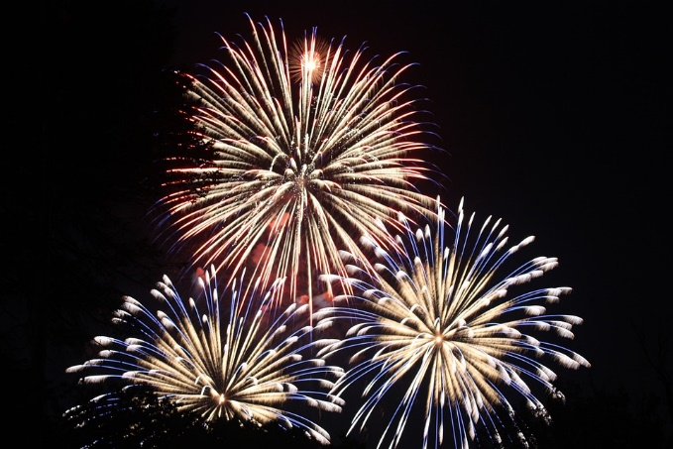
Town of Bayfield 4th of July
Sponsorship Opportunities
OPTION #1
The Exclusive Parade Presenting Sponsor

OPTION #2 (Sold to Clearnetworx)
The Exclusive Joe Stephenson Park Presenting Sponsor would include the following:
Title Sponsor for the park: “Business Name” presents the 2024 Bayfield 4th of July activities with vendors and games in Joe Stephenson Park.
Title sponsor acknowledgement on any paid radio advertising.
Logo placement on all print and social media to include posters, flyers, and print advertising.
Co-branding to use in your own media.
Vendor space up to 12x24’ * Prominent banner in the park
Sponsor Investment: $1000
(only ONE of these is available – first come, first served)

OPTION #3
The Exclusive Music Stage Sponsor would include the following:
Title Sponsor for the Music Stage: “Business Name” presents the 2024 Bayfield 4th of July Music in Joe Stephenson Park.
Title sponsor acknowledgement on any paid radio advertising.
Logo placement on all print and social media to include posters, flyers, and print advertising.
Co-branding to use in your own media.
Vendor space up to 12x24’ * Prominent banner in the park
Sponsor Investment: $1000
(only ONE of these is available – first come, first served)

OPTION #4
We are also offering an unlimited number of our Booster sponsorships, which would include:
Logo placement on all print and social media to include posters, flyers, and print advertising.
Co-branding to use in your own media.
Vendor space up to 12x24’ * Banner in the park
Sponsor Investment: $500
  - 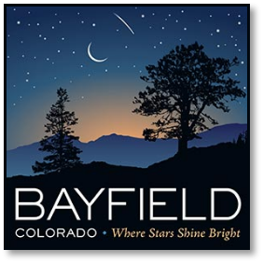

Additional donations are welcomed!
Contact djpacheco@bayfieldgov.org or (970) 884-9544 ext. 102

Sponsoring Agency: _________________________________________________________________________________

Sponsorship Type:____________________________________________________________________________

Name: __________________________ Email: __________________________________________

Mailing Address: _____________________________ City: _______________ Zip: __________

Physical Address: _____________________________ City: _______________ Zip: __________

Phone: _______________________________________

FOR DEPARTMENT USE ONLY
Payment Method: ______________ Amount Received: ___________
Check Number: ______________ Logo Received: Yes No

Bayfield Parks & Recreation Please mail checks to:
Bayfieldgov.org P.O. Box 80
(970) 884-9544 Bayfield, CO 81122

